**ASSIGNMENT 3**

|  |  |
| --- | --- |
| Team ID | PNT2022TMID07098  **Explore AS, differentiate** |
| Project Name | Project - Nutrition Assistance Application |
| Name | Sivasankari R |
| Batch | B8-2A4E |

**1.Create a Bucket in IBM object storage.**

**2.Upload an 5 images to ibm object storage and make it public. write html code to**

**3. Upload a a css page to the object storage and use the same page in your HTML code.**

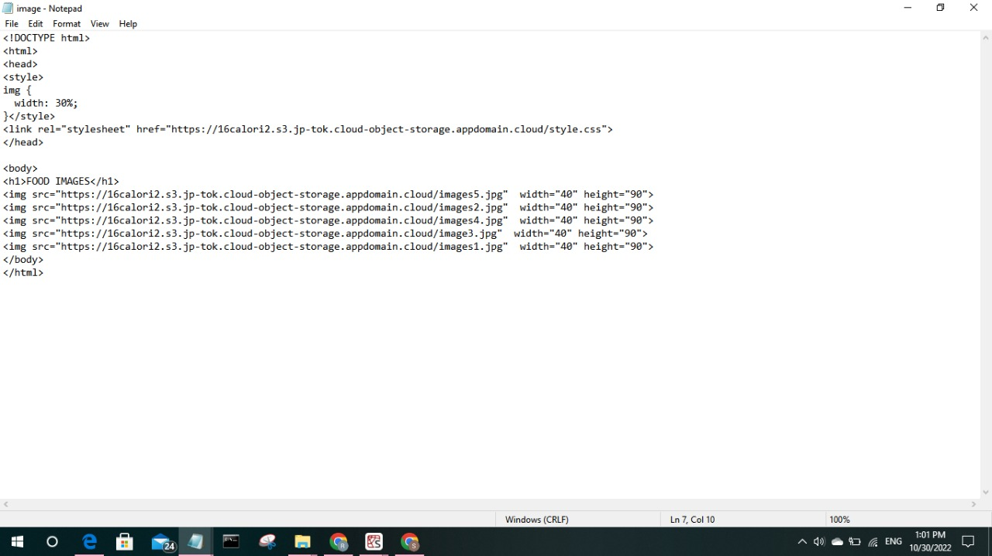

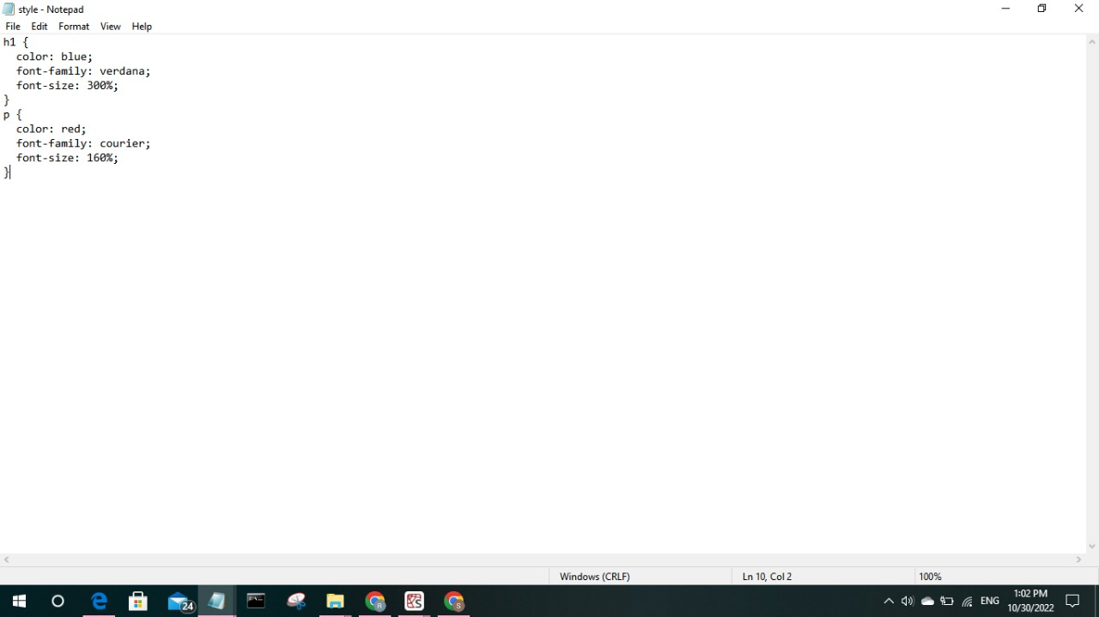

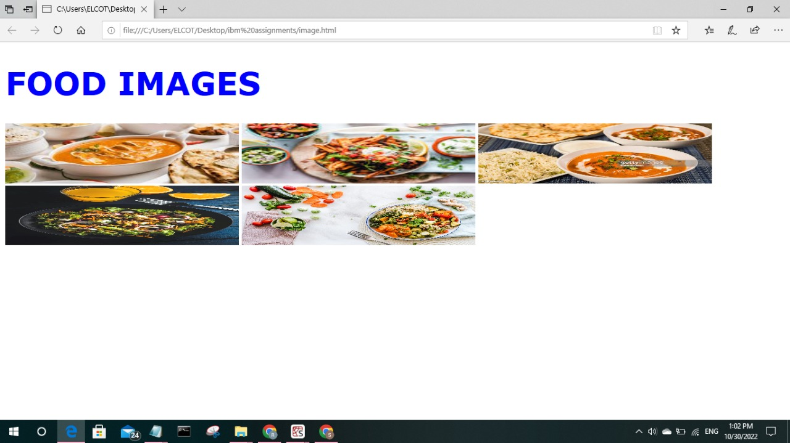

**4.Desig a chatbot using IBM Watson assistant for hospital. Ex: User comes with query to know the branches for that hospital in your city. Submit the web URL of that chat bot as a assignment**

**5.Create Watson assistant service with 10 steps and use 3 conditions in it. Load that script in HTML page.**

The below link is the link for Watson assistance for above questions. The Watson assistance have 10 actions and have 3 conditions

https://web-chat.global.assistant.watson.appdomain.cloud/preview.html?backgroundImageURL=https%3A%2F%2Fus-south.assistant.watson.cloud.ibm.com%2Fpublic%2Fimages%2Fupx-7c0412b7-77c1-4f0a-a901-8c10e1bd9219%3A%3A2f49bc52-bc95-450c-9b95-b01dbdc13638&integrationID=623701bc-9df6-47e9-bf54-00378afd6b0c&region=us-south&serviceInstanceID=7c0412b7-77c1-4f0a-a901-8c10e1bd9219